Inexpensive Vacations - California & Nevada National Parks   
  
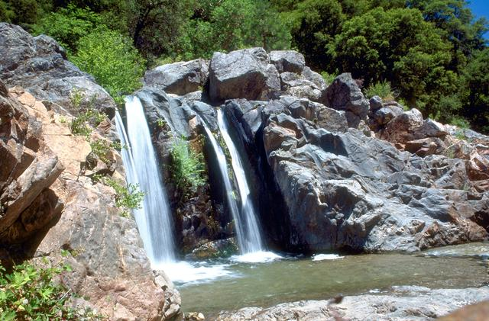

1. California National Historic Trail

Various States, CA,CO,ID,KS,MO,NE,NV,OR,UT,WY Follow in the footsteps of over 250,000 emigrants who traveled to the gold fields and rich farmlands of California during the 1840s and 1850s-the greatest mass migration in American history. More than 1,000 miles of trail ruts and traces can still be seen across 10 states on the California National Historic Trail. (Source: U S National Park Service)

Read more: [http://www.mycouponbuddy.com#ixzz4EWM5sYa7](http://www.mycouponbuddy.com/#ixzz4EWM5sYa7)

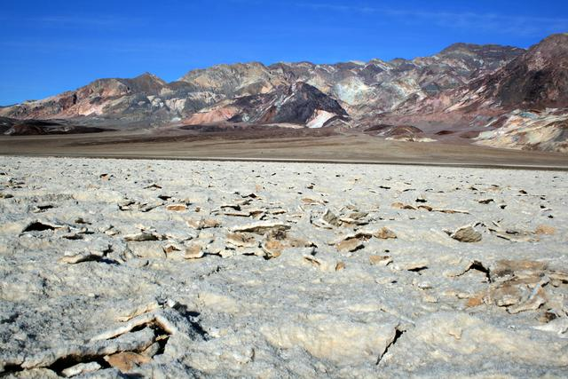

2. Death Valley National Park

Death Valley, CA,NV In this below-sea-level basin, steady drought and record summer heat make Death Valley a land of extremes. Yet, each extreme has a striking contrast. Towering peaks are frosted with winter snow. Rare rainstorms bring vast fields of wildflowers. Lush oases harbor tiny fish and refuge for wildlife and humans. Despite its morbid name, a great diversity of life survives in Death Valley. (Source: U S National Park Service)

Read more: [http://www.mycouponbuddy.com#ixzz4EWM9ERlv](http://www.mycouponbuddy.com/#ixzz4EWM9ERlv)

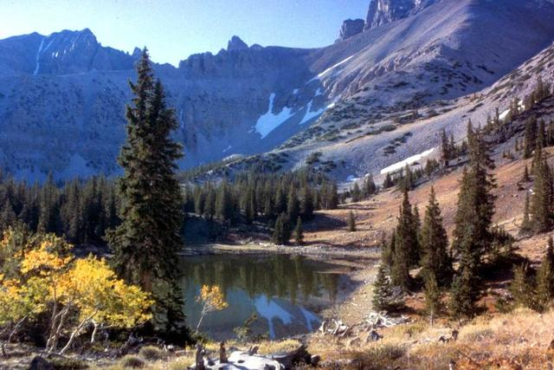

3. Great Basin National Park

Baker, NV In the shadow of 13,063-foot Wheeler Peak, 5,000-year-old bristlecone pine trees grow on rocky glacial moraines. Come to Great Basin National Park to experience the solitude of the desert, the smell of sagebrush after a thunderstorm, the darkest of night skies, and the beauty of Lehman Caves. Far from a wasteland, the Great Basin is a diverse region that awaits your discovery. (Source: U S National Park Service)

Read more: [http://www.mycouponbuddy.com#ixzz4EWMC2N2w](http://www.mycouponbuddy.com/#ixzz4EWMC2N2w)

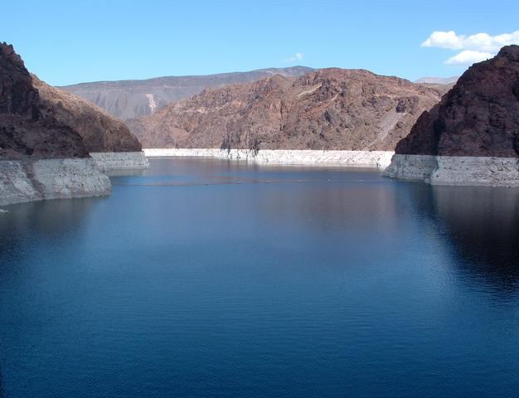

4. Lake Mead national Recreation Area

the Mojave Desert, AZ,NV Lake Mead NRA offers year-round recreational opportunities for boating, fishing, hiking, photography, picnicking and sightseeing. It is also home to thousands of desert plants and animals, adapted to survive where rain is scarce and temperatures can soar. (Source: U S National Park Service)

Read more: [http://www.mycouponbuddy.com#ixzz4EWMFokyy](http://www.mycouponbuddy.com/#ixzz4EWMFokyy)

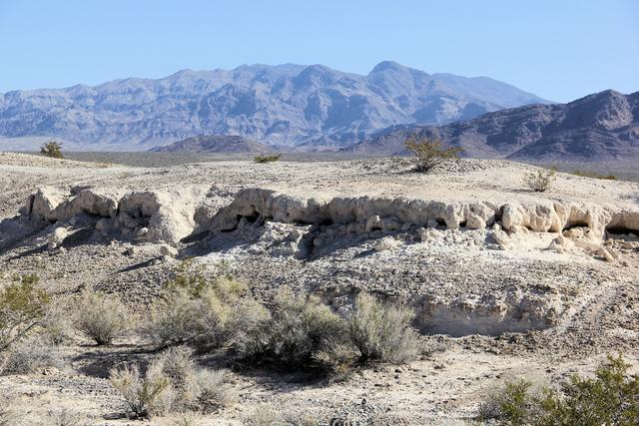

5. Tule Springs Fossil Beds National Monument

NV Mammoths, lions and camels once roamed along wetlands just north of what is now known as Las Vegas, Nevada. Their history is preserved at Tule Springs Fossil Beds National Monument and is ready to be discovered. (Source: U S National Park Service)

Read more: [http://www.mycouponbuddy.com#ixzz4EWMHvOv6](http://www.mycouponbuddy.com/#ixzz4EWMHvOv6)

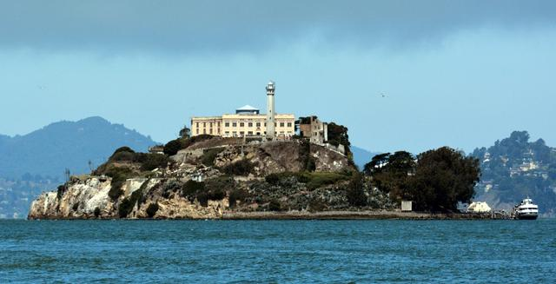

6. Alcatraz Island

San Francisco, CA Alcatraz Island offers a close-up look at the site of the first lighthouse and US built fort on the West Coast, the infamous federal penitentiary long off-limits to the public, and the history-making 18-month occupation by Indians of All Tribes. Rich in history, there is also a natural side to the Rock—gardens, tide pools, bird colonies, and bay views beyond compare. (Source: U S National Park Service)

Read more: [http://www.mycouponbuddy.com#ixzz4EWMKHySG](http://www.mycouponbuddy.com/#ixzz4EWMKHySG)

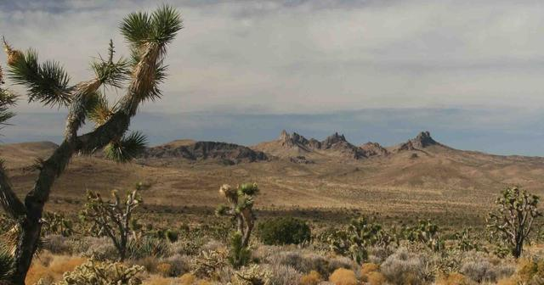

7. Castle Mountains National Monument

Barstow, CA Castle Mountains represents some of the most unique elements of the Mojave Desert. Nestled between the Nevada state line and Mojave National Preserve, the nearly 21,000 acres of Castle Mountains boasts Joshua tree forests, unbroken natural landscapes, rare desert grasslands, and rich human history. This intriguing area provides serenity and solitude from nearby metropolitan areas. (Source: U S National Park Service)

Read more: [http://www.mycouponbuddy.com#ixzz4EWMNsfLZ](http://www.mycouponbuddy.com/#ixzz4EWMNsfLZ)

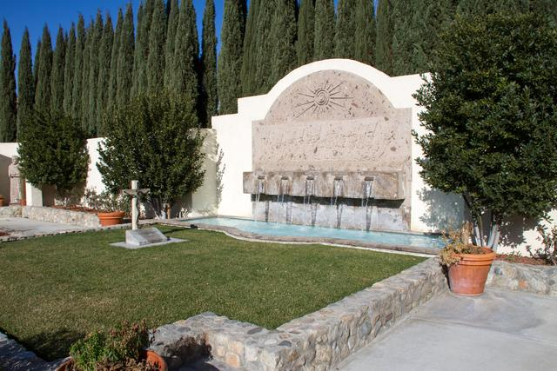

8. César E. Chávez National Monument

Keene, CA Yes, we can! Widely recognized as the most important Latino leader in the United States during the twentieth century, César E. Chávez led farm workers and supporters in the establishment of the country's first permanent agricultural union. His leadership brought sustained international attention to the plight of U.S. farm workers, and secured for them higher wages and safer working conditions (Source: U S National Park Service)

Read more: [http://www.mycouponbuddy.com#ixzz4EWMPmeW6](http://www.mycouponbuddy.com/#ixzz4EWMPmeW6)

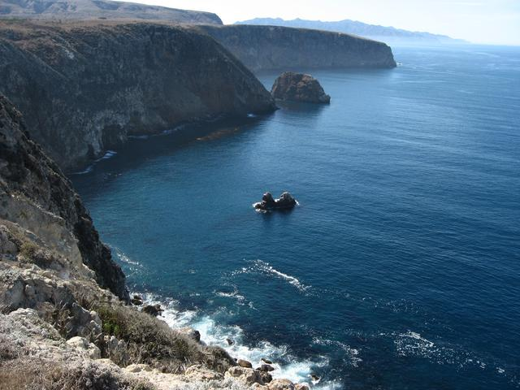

9. Channel Islands National Park

Ventura, CA Channel Islands National Park encompasses five remarkable islands and their ocean environment, preserving and protecting a wealth of natural and cultural resources. Isolation over thousands of years has created unique animals, plants, and archeological resources found nowhere else on Earth and helped preserve a place where visitors can experience coastal southern California as it once was. (Source: U S National Park Service)

Read more: [http://www.mycouponbuddy.com#ixzz4EWMRZzej](http://www.mycouponbuddy.com/#ixzz4EWMRZzej)

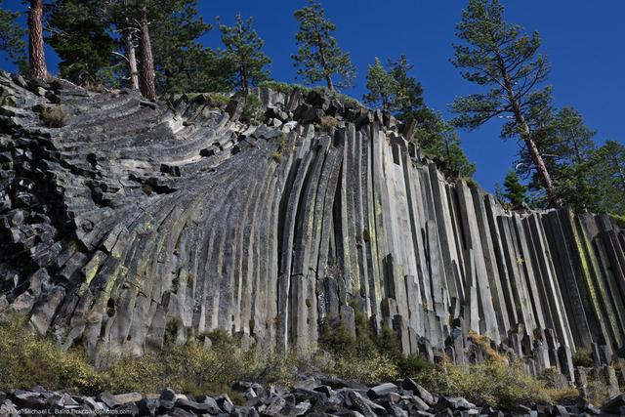

10. Devils Postpile National Monument

the Sierra Nevada near Mammoth Lakes, CA Established in 1911 by presidential proclamation, Devils Postpile National Monument protects and preserves the Devils Postpile formation, the 101-foot high Rainbow Falls, and pristine mountain scenery. The formation is a rare sight in the geologic world and ranks as one of the world's finest examples of columnar basalt. Its columns tower 60 feet high and display an unusual symmetry. (Source: U S National Park Service)

Read more: [http://www.mycouponbuddy.com#ixzz4EWMVEx27](http://www.mycouponbuddy.com/#ixzz4EWMVEx27)

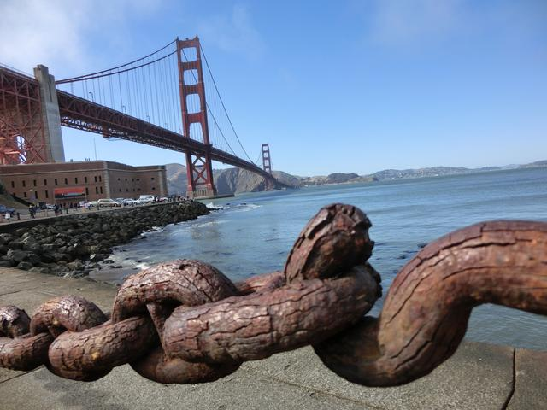

11. Fort Point National Historic Site

Presidio of San Francisco, CA From its vantage point overlooking the spectacular Golden Gate, Fort Point defended the San Francisco Bay following California's Gold Rush through World War II. Its beautifully arched casemates display the art of 3rd system brick masonry and interacts gracefully with the Golden Gate Bridge. (Source: U S National Park Service)

Read more: [http://www.mycouponbuddy.com#ixzz4EWMXCpRp](http://www.mycouponbuddy.com/#ixzz4EWMXCpRp)

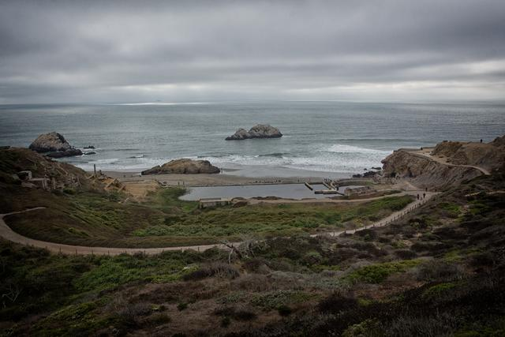

12. Golden Gate National Recreation Area

San Francisco, CA The park chronicles 200 years of history from Native American culture, Spanish Empire frontier, the Gold Rush, evolution of American coastal fortifications and growth of urban San Francisco. Comprised of 19 separate ecosystems and home to 1,273 plant/animal species, the park has hundreds of ways to recreate including horseback riding, ranger-led programs, bicycling, hiking and walking your dog. (Source: U S National Park Service)

Read more: [http://www.mycouponbuddy.com#ixzz4EWMZAnLn](http://www.mycouponbuddy.com/#ixzz4EWMZAnLn)

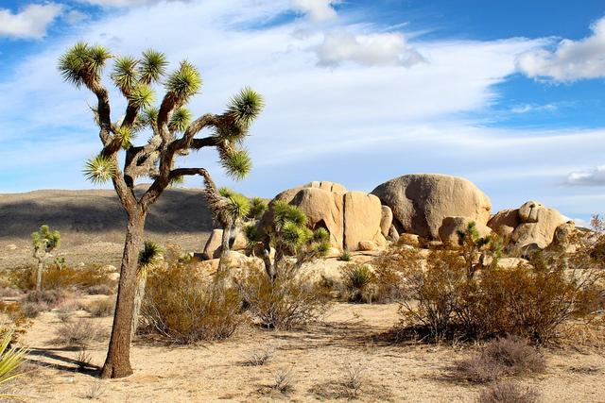

13. Joshua Tree National Park

Southern California between I-10 and Hwy 62; headquarters in Twentynine Palms, CA Two distinct desert ecosystems, the Mojave, and the Colorado, come together in Joshua Tree National Park. A fascinating variety of plants and animals make their homes in a land sculpted by strong winds and occasional torrents of rain. Dark night skies, a rich cultural history, and surreal geologic features add to the wonder of this vast wilderness in southern California. Come explore for yourself. (Source: U S National Park Service)

Read more: [http://www.mycouponbuddy.com#ixzz4EWMcy4bs](http://www.mycouponbuddy.com/#ixzz4EWMcy4bs)

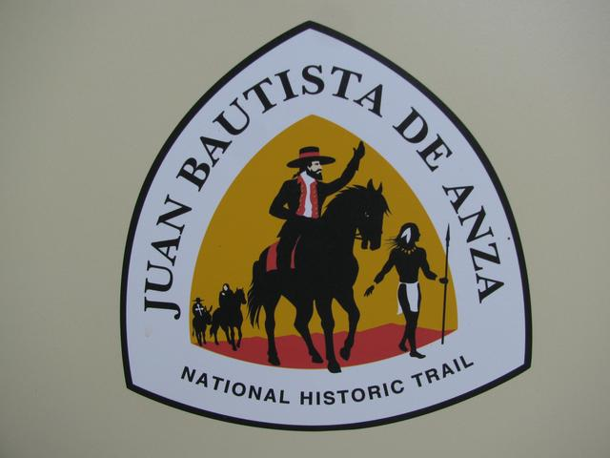

14. Juan Bautista de Anza National Historic Trail

Nogales, AZ to San Francisco, CA, AZ,CA "Everyone mount up!" was the rousing call from Juan Bautista de Anza. In 1775-76, Anza led some 240 men, women, and children on an epic journey to establish the first non-Native settlement at San Francisco Bay. Today, the 1,200-mile Juan Bautista de Anza National Historic Trail connects history, culture, and outdoor recreation from Nogales, Arizona, to the San Francisco Bay Area. (Source: U S National Park Service)

Read more: [http://www.mycouponbuddy.com#ixzz4EWMeiBUr](http://www.mycouponbuddy.com/#ixzz4EWMeiBUr)

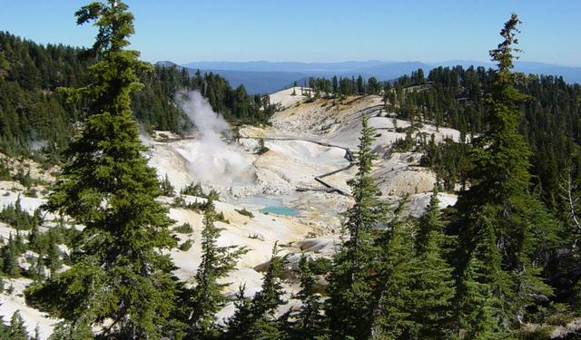

15. Lassen Volcanic National Park

Mineral, CA Lassen Volcanic National Park is home to steaming fumaroles, meadows freckled with wildflowers, clear mountain lakes, and numerous volcanoes. Jagged peaks tell the story of its eruptive past while hot water continues to shape the land. Lassen Volcanic offers opportunities to discover the wonder and mysteries of volcanoes and hot water for visitors willing to explore the undiscovered. (Source: U S National Park Service)

Read more: [http://www.mycouponbuddy.com#ixzz4EWMgVvhs](http://www.mycouponbuddy.com/#ixzz4EWMgVvhs)

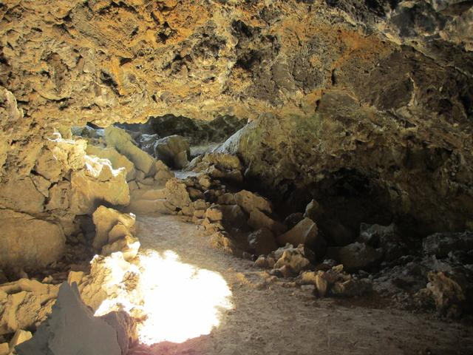

16. Lava Beds National Monument

Tulelake, CA Lava Beds National Monument is a land of turmoil, both geological and historical. Over the last half-million years, volcanic eruptions on the Medicine Lake shield volcano have created a rugged landscape dotted with diverse volcanic features. More than 700 caves, Native American rock art sites, historic battlefields and campsites, and a high desert wilderness experience await you! (Source: U S National Park Service)

Read more: [http://www.mycouponbuddy.com#ixzz4EWMlswCZ](http://www.mycouponbuddy.com/#ixzz4EWMlswCZ)

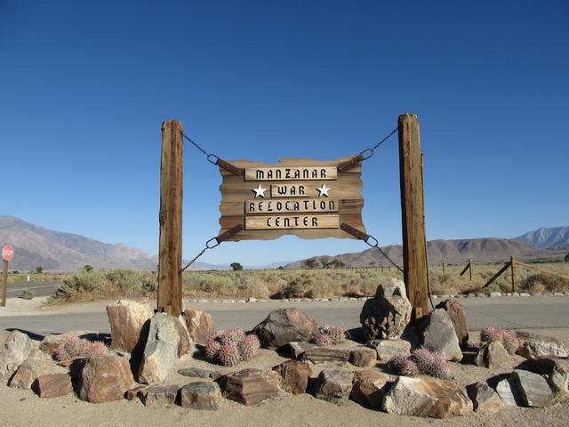

17. Manzanar National Historic Site

Independence, CA In 1942, the United States government ordered more than 110,000 men, women, and children to leave their homes and detained them in remote, military-style camps. Manzanar War Relocation Center was one of ten camps where Japanese American citizens and resident Japanese aliens were interned during World War II. (Source: U S National Park Service)

Read more: [http://www.mycouponbuddy.com#ixzz4EWMnUz4Q](http://www.mycouponbuddy.com/#ixzz4EWMnUz4Q)

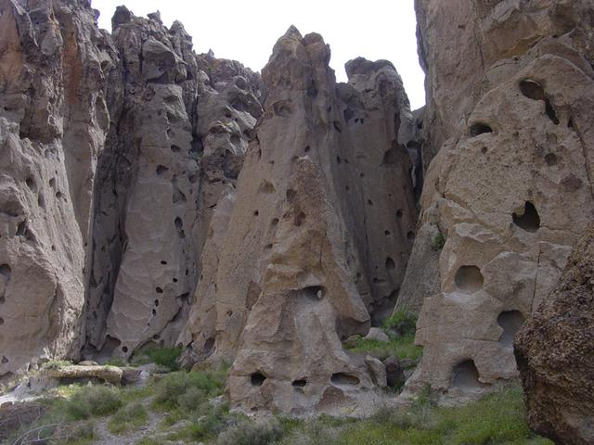

18. Mojave National Preserve

Southern California between I-15 and I-40; headquarters in Barstow, CA Singing sand dunes, volcanic cinder cones, Joshua tree forests, and carpets of wildflowers are all found at this 1.6 million acre park. A visit to its canyons, mountains and mesas will reveal long-abandoned mines, homesteads, and rock-walled military outposts. Located between Los Angeles and Las Vegas, Mojave provides serenity and solitude from major metropolitan areas. (Source: U S National Park Service)

Read more: [http://www.mycouponbuddy.com#ixzz4EWMpD9En](http://www.mycouponbuddy.com/#ixzz4EWMpD9En)

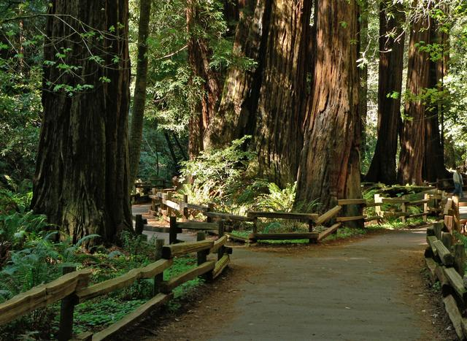

19. Muir Woods National Monument

Mill Valley, CA When John Muir learned that William and Elizabeth Kent were naming a redwood forest near San Francisco in his honor, he declared, "This is the best tree-lovers monument that could possibly be found in all the forests of the world." The couple had purchased the land to preserve its beauty and restful wilderness; and in 1908, they donated it to the federal government to protect it from destruction. (Source: U S National Park Service)

Read more: [http://www.mycouponbuddy.com#ixzz4EWMsdmCM](http://www.mycouponbuddy.com/#ixzz4EWMsdmCM)

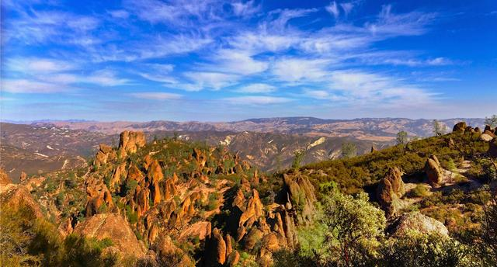

20. Pinnacles National Park

Paicines, CA Some 23 million years ago multiple volcanoes erupted, flowed, and slid to form what would become Pinnacles National Park. What remains is a unique landscape. Travelers journey through chaparral, oak woodlands, and canyon bottoms. Hikers enter rare talus caves and emerge to towering rock spires teeming with life: prairie and peregrine falcons, golden eagles, and the inspiring California condor. (Source: U S National Park Service)

Read more: [http://www.mycouponbuddy.com#ixzz4EWMuWfLf](http://www.mycouponbuddy.com/#ixzz4EWMuWfLf)

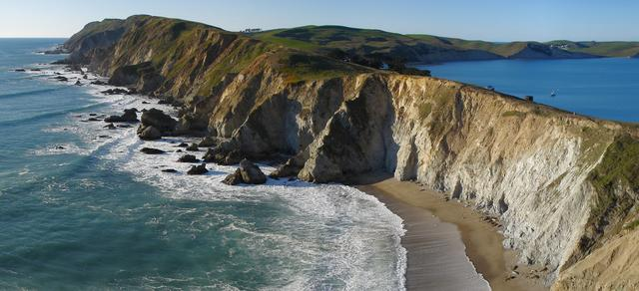

21. Point Reyes National Seashore

Point Reyes, CA From its thunderous ocean breakers crashing against rocky headlands and expansive sand beaches to its open grasslands, brushy hillsides, and forested ridges, Point Reyes offers visitors over 1500 species of plants and animals to discover. Home to several cultures over thousands of years, the Seashore preserves a tapestry of stories and interactions of people. Point Reyes awaits your exploration. (Source: U S National Park Service)

Read more: [http://www.mycouponbuddy.com#ixzz4EWMwNXyI](http://www.mycouponbuddy.com/#ixzz4EWMwNXyI)

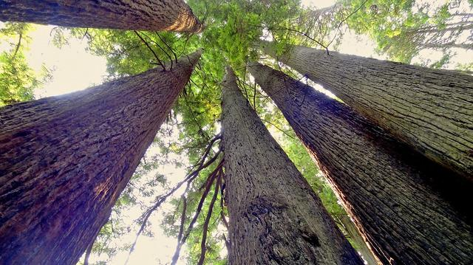

22. Redwood National and State Parks

Del Norte & Humboldt counties , CA Most people know Redwood as home to the tallest trees on Earth. The parks also protect vast prairies, oak woodlands, wild riverways, and nearly 40 miles of rugged coastline. For thousands of years people have lived in this verdant landscape. Together, the National Park Service and California State Parks manage these lands for the inspiration, enjoyment, and education of all. (Source: U S National Park Service)

Read more: [http://www.mycouponbuddy.com#ixzz4EWN0AdfO](http://www.mycouponbuddy.com/#ixzz4EWN0AdfO)

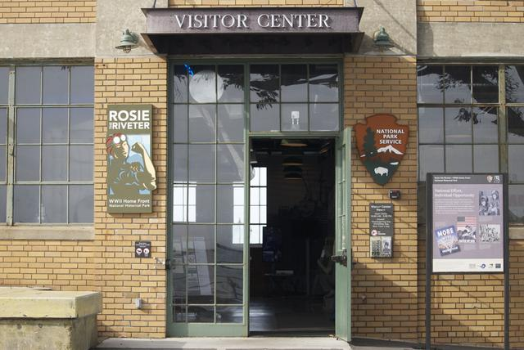

23. Rosie the Riverter WWII Home Front

Richmond, CA Explore and honor the efforts and sacrifices of American civilians on the World War II home front. Find out how they lived, worked and got along. Many faces, many stories, many truths weave a complex tapestry of myths and realities from this time of opportunity and loss. (Source: U S National Park Service)

Read more: [http://www.mycouponbuddy.com#ixzz4EWN2fLy9](http://www.mycouponbuddy.com/#ixzz4EWN2fLy9)

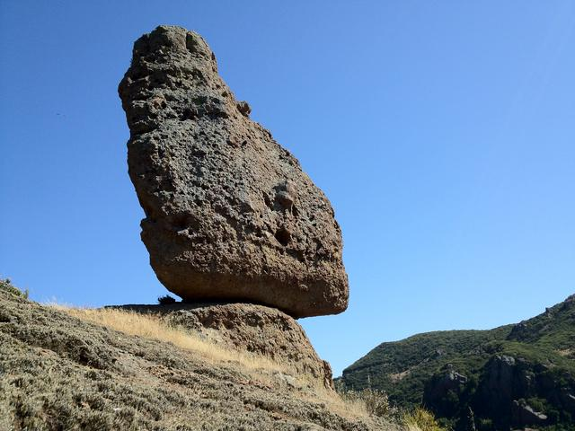

24. Santa Monica Mountains National Recreation Area

Thousand Oaks, CA Hidden in plain sight from Los Angeles, the Santa Monica Mountains offer easy access to surprisingly wild places. Experience the famous beaches of Malibu or explore more than 500 miles of trails. The park abounds with historical and cultural sites, from old movie ranches to Native American centers. What will you and your family discover? (Source: U S National Park Service)

Read more: [http://www.mycouponbuddy.com#ixzz4EWN4bD3P](http://www.mycouponbuddy.com/#ixzz4EWN4bD3P)

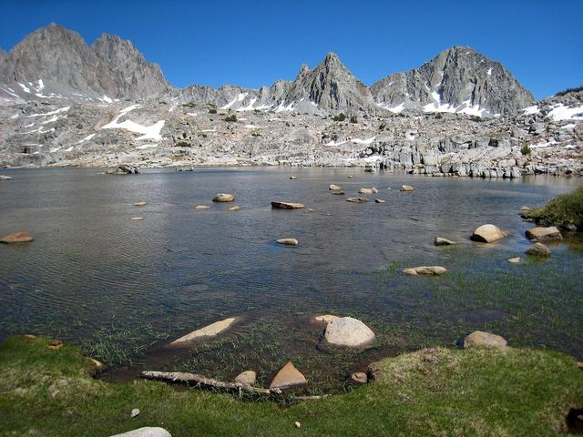

25. Sequoia & Kings Canyon National Parks

In the southern Sierra Nevada in Tulare and Fresno counties, CA This dramatic landscape testifies to nature's size, beauty, and diversity--huge mountains, rugged foothills, deep canyons, vast caverns, and the world's largest trees. These two parks lie side by side in the southern Sierra Nevada east of the San Joaquin Valley. Weather varies a lot by season and elevation, which ranges from 1,370' to 14,494'. Sequoias grow at 5,000 - 7,000', above usual snowline. (Source: U S National Park Service)

Read more: [http://www.mycouponbuddy.com#ixzz4EWN86lHy](http://www.mycouponbuddy.com/#ixzz4EWN86lHy)

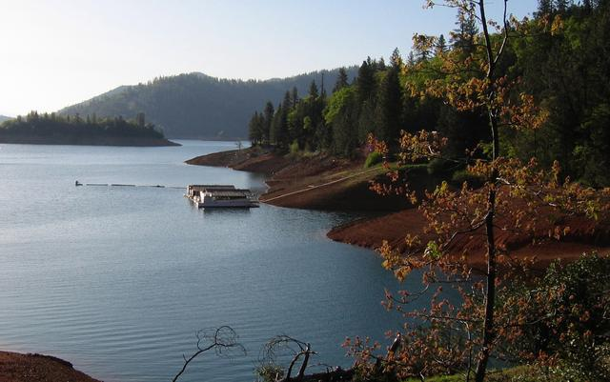

26. Whiskeytown National Recreation Area

Whiskeytown, CA Whiskeytown Lake’s beautiful crystal-clear waters, surrounded by mountain peaks, are perhaps the most prominent feature of the park. However, water-based recreation is only a small part of what the park has to offer. The 39,000 acres surrounding the lake hold four waterfalls, pristine mountain creeks, 70 miles of trails, and opportunities to explore the history of the California Gold Rush. (Source: U S National Park Service)

Read more: [http://www.mycouponbuddy.com#ixzz4EWN9tbva](http://www.mycouponbuddy.com/#ixzz4EWN9tbva)

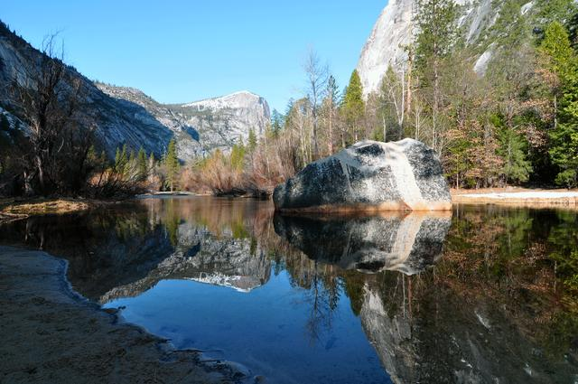

27. Yosemite National Park

the Sierra Nevada, CA Not just a great valley, but a shrine to human foresight, the strength of granite, the power of glaciers, the persistence of life, and the tranquility of the High Sierra. First protected in 1864, Yosemite National Park is best known for its waterfalls, but within its nearly 1,200 square miles, you can find deep valleys, grand meadows, ancient giant sequoias, a vast wilderness area, and much more. (Source: U S National Park Service)

Read more: [http://www.mycouponbuddy.com#ixzz4EWNBog9n](http://www.mycouponbuddy.com/#ixzz4EWNBog9n)